SOFTWARE REQUIREMENTS SPECIFICATION

**For**

**Online Quiz system**

**Prepared by:-**

*Karthi A S*

*Jegatheeshan R*

*Kavin M*

# Introduction

# Purpose:

## This a Web application that provides facility to graduating/learning student. It provides a competitive platform, where a student not only judges their knowledge/skill but also they can improve their knowledge/skill at the same time. It can take test of a large collection of candidate at same time and display score card & solution online.

# Scope of Development Project:

## 

## The main objective of this project is to conduct online test which will help them to become self paced learners and to make them aware of examination pattern of many competitive exams such as GATE, TOFEL, and various PSUs .Some of the aim of the project includes:-

## Help students to go beyond their normal curriculum and learn about various other aspects which are apart from academic education

## To provide an examination system where, there is virtually no scope of errors and the results are much faster. And the system is more transparent

## To provide an environment where students not only can learn but also analyze their performance simultaneously

## USER CLASS:

## 

## **User ID**: A unique identifier for each user.

## Username: A user's unique login identifier.

## Password: Securely stored password for authentication.

## Role: Different roles (e.g., student, instructor, administrator) determining user permissions.

## Email Address: Contact information for notifications and communication.

## Profile Picture: An optional image to personalize the user's account.

# External Interface Requirement

# User Interface:

**Provide a user-friendly registration and login interface for participants.**

**Include options for password recovery and account management.**

**Administrator Interface:**

**Interface for adding, modifying, and deleting user accounts.**

**Differentiate between user roles (admin, instructor, participant).**

# 2.System Features

Description and Priority:

**Proposed Database is intended to store, retrieve, update, and manipulate**

**information related to university which include**

**➢* Profile of both users**

**\* Student details**

**➢* My account**

**\* Test results**

**\* Stimulus / Response Sequences**

Responses for Administrator:

**The administrator can Login and Logout. When the Administrator Logs**

**into the Online Exam system. The system will check for validity of login**

**. If the Login and password are valid, the response to this action is the**

**administrator will be able to modify, view, add, deleting and all other**

**functions that can be performed on the database.**

# Security Requirements:

**Security is of paramount importance in the online quiz project to safeguard user data, maintain the integrity of quizzes, and prevent unauthorized access or manipulation. The system must implement robust authentication mechanisms, incorporating secure user login processes, and optionally, multi-factor authentication for enhanced security. All sensitive information, including user credentials, should be securely encrypted during transmission and storage to protect against unauthorized access. Role-based access control should be enforced, restricting users to functionalities based on their roles (student, instructor, administrator). The DBMS should be configured with strict access controls to prevent unauthorized alterations to the quiz data. Additionally, the system should guard against common security threats, including SQL injection, cross-site scripting (XSS), and cross-site request forgery (CSRF). Regular security audits and updates to address emerging vulnerabilities are essential components of maintaining a secure online quiz system. Compliance with relevant privacy regulations and guidelines should also be ensured to protect user privacy and data. By implementing these security measures, the online quiz project can create a trustworthy and secure environment for users and administrators alike**

# User Requirments:

**The user requirements for the online quiz system, developed with Java and a Database Management System**

**(DBMS), encompass a user-friendly experience tailored to the distinct needs of students, instructors, and administrators. Students anticipate an intuitive interface for quiz participation, enabling easy navigation, submission of answers, and prompt feedback. Instructors seek comprehensive quiz creation tools, question bank integration, and analytics to assess student performance. Administrators necessitate robust user management, system configuration options, and detailed analytics for overall system oversight. Common to all users are expectations of secure data handling, stringent authentication measures, and seamless accessibility across devices. The online quiz system is designed to deliver a cohesive, efficient, and secure platform, fostering a positive learning environment for all stakeholders**

Class diagram:

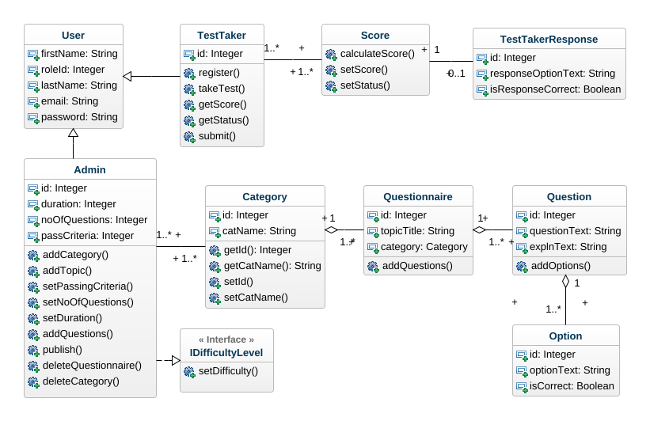

## Use case diagram

